RESOLUTION NO.__________

RE: CERTIFICATE OF APPROPRIATENESS UNDER THE
PROVISIONS OF THE ACT OF THE PENNSYLVANIA
LEGISLATURE 1961, JUNE 13, P.L. 282 (53
SECTION 8004) AND BETHLEHEM ORDINANCE NO.
3952 AS AMENDED.

The applicant proposes to paint the façade with a new color palette and new awning fabric will be added at 428-444 Main St.

NOW, THEREFORE, BE IT RESOLVED by the Council of the City of Bethlehem that a Certificate of Appropriateness is hereby granted for the proposal.

Sponsored by: (s)

(s)

ADOPTED BY COUNCIL THIS DAY OF

(s)
President of Council

ATTEST:

(s)
City Clerk

HISTORICAL & ARCHITECTURAL REVIEW BOARD

The applicant proposes to paint the façade with a new color palette and new awning fabric will be added at 428-444 Main St.

APPLICATION #2:

Moravian College
1200 Main St.
Bethlehem, PA 18018

OWNER:

__________________________________________________________________________

The Board upon motion by Marsha Fritz and seconded by Connie Glagola adopted the proposal that City Council issue a Certificate of Appropriateness for the following:

- Approve the new color palette (excluding light blues) to be applied to the building
only.

2. The motion was unanimously approved.

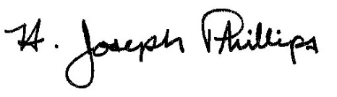 By:__H. Joseph Phillips___________

Title: __Historic Officer____________

Date of Meeting: October 3, 2018

